Mobile App Development 2

Design Document

Author: Bernard Wong

Student ID: G00341962

Email: [G00341962@gmit.ie](mailto:G00341962@gmit.ie)

# Overview

A fitness companion application that tracks user’s height, weight and nutrition intakes, also with a BMI calculator.

# Table of Content

Contents

Overview 1

Table of Content 1

Context 3

Goals 3

Existing Solution 3

Proposed Solution 4

Alternative Solution 4

Design Draft 5

Login Page 5

Tracker Page 5

BMI Calculator Page 6

Account Page 6

# Context

The purpose of this application is to help users keep track of their body fitness. Users can set goals on how much intake needed in a day and record daily intake.

# Goals

* Standard login function (username/password) (JSON)
* Save/Update/Delete food intakes (JSON)
* Split intakes into 4 categories (breakfast, lunch, dinner, snacks)
* Display each category of nutrition totals
* Display whole total nutrition value
* Compare the user’s nutrition goal and current intakes

# Existing Solution

* User logs in the app using an available account or register an account.
* The user then sees the tables of intakes with their nutrition values, the total nutrition values, user’s daily nutrition goals and remaining nutrition to hit the goal.
* User can add/delete intakes easily.
* Another page is a BMI calculator where user can input height and weight to calculate BMI.
* 3rd page is where the user manages their account and the last page is the About page of the app.

# Proposed Solution

* Accounts are stored in JSON format, unable to register the same username.
* Intakes are stored in another JSON file and split up to 4 categories (breakfast, lunch, dinner, snacks) and mapped to the user’s account.
* Totals, user goals, remaining should changes when the user made changes to any of the parameters.
* Default values for BMI calculator weight and height can be the user’s own parameters.
* Use INotifyPropertyChanged on User account parameters.

# Alternative Solution

* Mapping Intakes to the user’s account is optional as no reason to share this app with different users. This app is suitable for a single individual.
* Use MongoDB instead of JSON.

# Design Draft

## Login Page

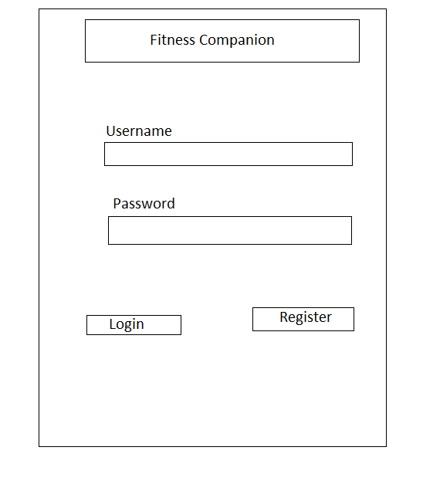

## Tracker Page

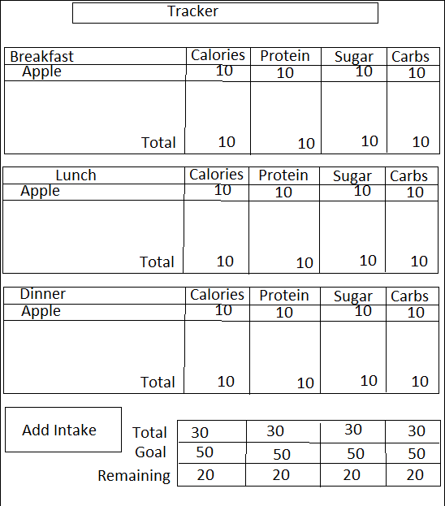

## BMI Calculator Page

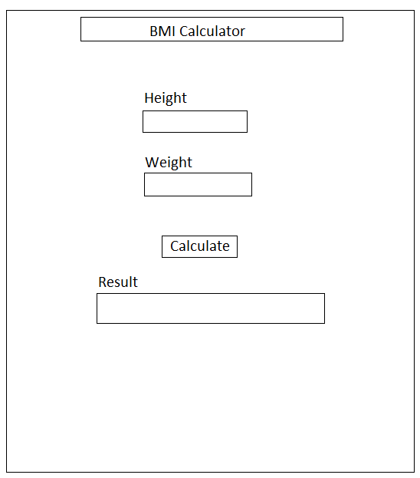

## Account Page

